**Unearthing the Environmental Impact of Human Activity: A Global CO2 Emission Analysis**

**INTRODUCTION**

OVERVIEW:

Global warming is one of the biggest challenges currently being faced by people, although correlation is not causation, a likely cause of global warming is due to increased atmospheric carbon dioxide from human activities. CO2 Emission refers to the Carbon Dioxide emitted throughout the world

For this analysis we will be focusing on CO2 Emissions and their effect on the world we live in as well as some key factors and stats that may play a role in the emission of CO2 globally. Fossil fuel use is the primary source of CO2. The data throws light onto how much fossil fuels are burnt, per year per nation, which amounts to an increase in CO2 every year. This will help researchers and environment experts to predict global warming. So, countries should set a goal to decrease this amount yearly. Analyzing Global Co2 Emission across countries from 1975 to 2020. This dataset contains a record of Co2 Emission by each Country and Region of Earth, here we are going to analyze and visualize Country wise, Region wise and Overall Co2 Emission on Earth.

PURPOSE

A literature survey for a project on “Unearthing the Environmental Impact of Human Activity: A Global CO2 Emission Analysis” would involve reviewing studies and articles that have been published on the topic of Emission, as well as studies specific to Co2.The literature survey would include sources such as academic journals, industry reports, and online articles. It would aim to identify different internal and external factors that are responsible and commonly used to determine Co2 Emission, as well as any best practices or strategies that have been identified for reducing emission .The literature survey would also explore any existing research on Co2 Emission specifically, and would aim to identify any challenges or opportunities that the Countries can opt to reduce emission. Unearthing the Environmental Impact of Human Activity:

***PROBLEM DEFINITION AND DESIGN THINKING***

***EMPATHY MAPPING***

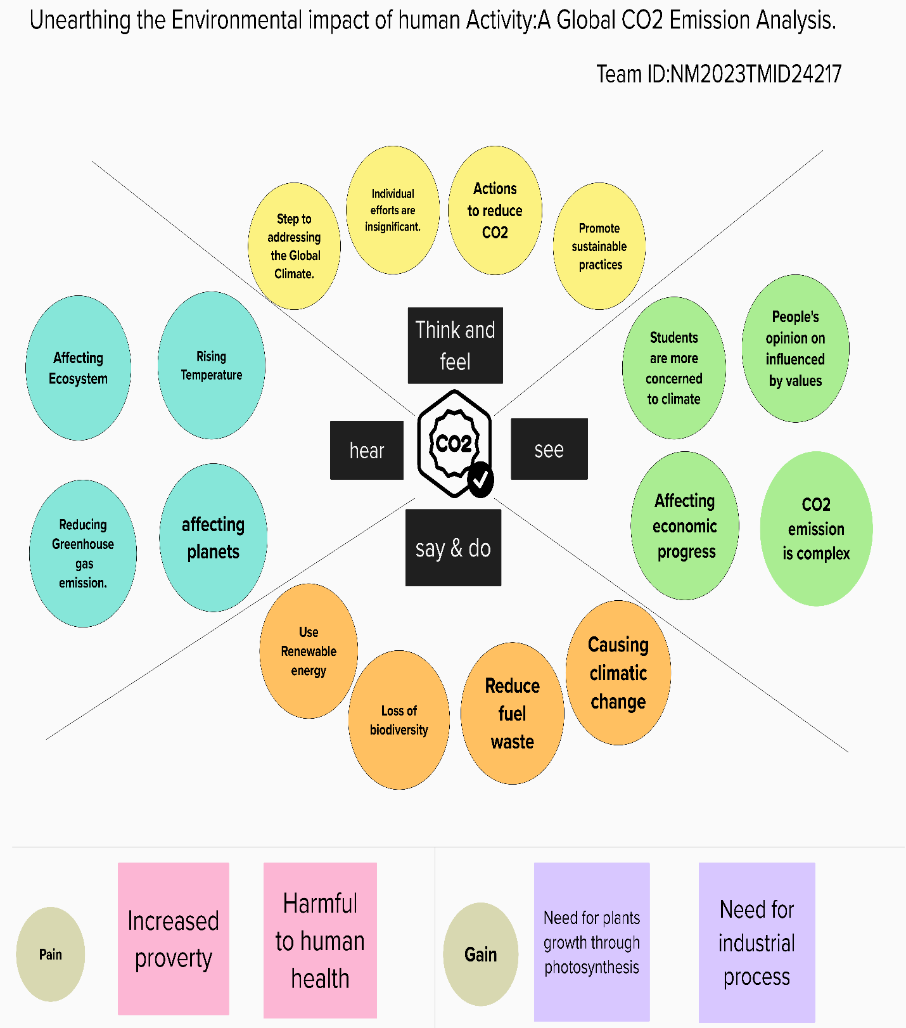

***BRAINSTROMING AND IDEATION***

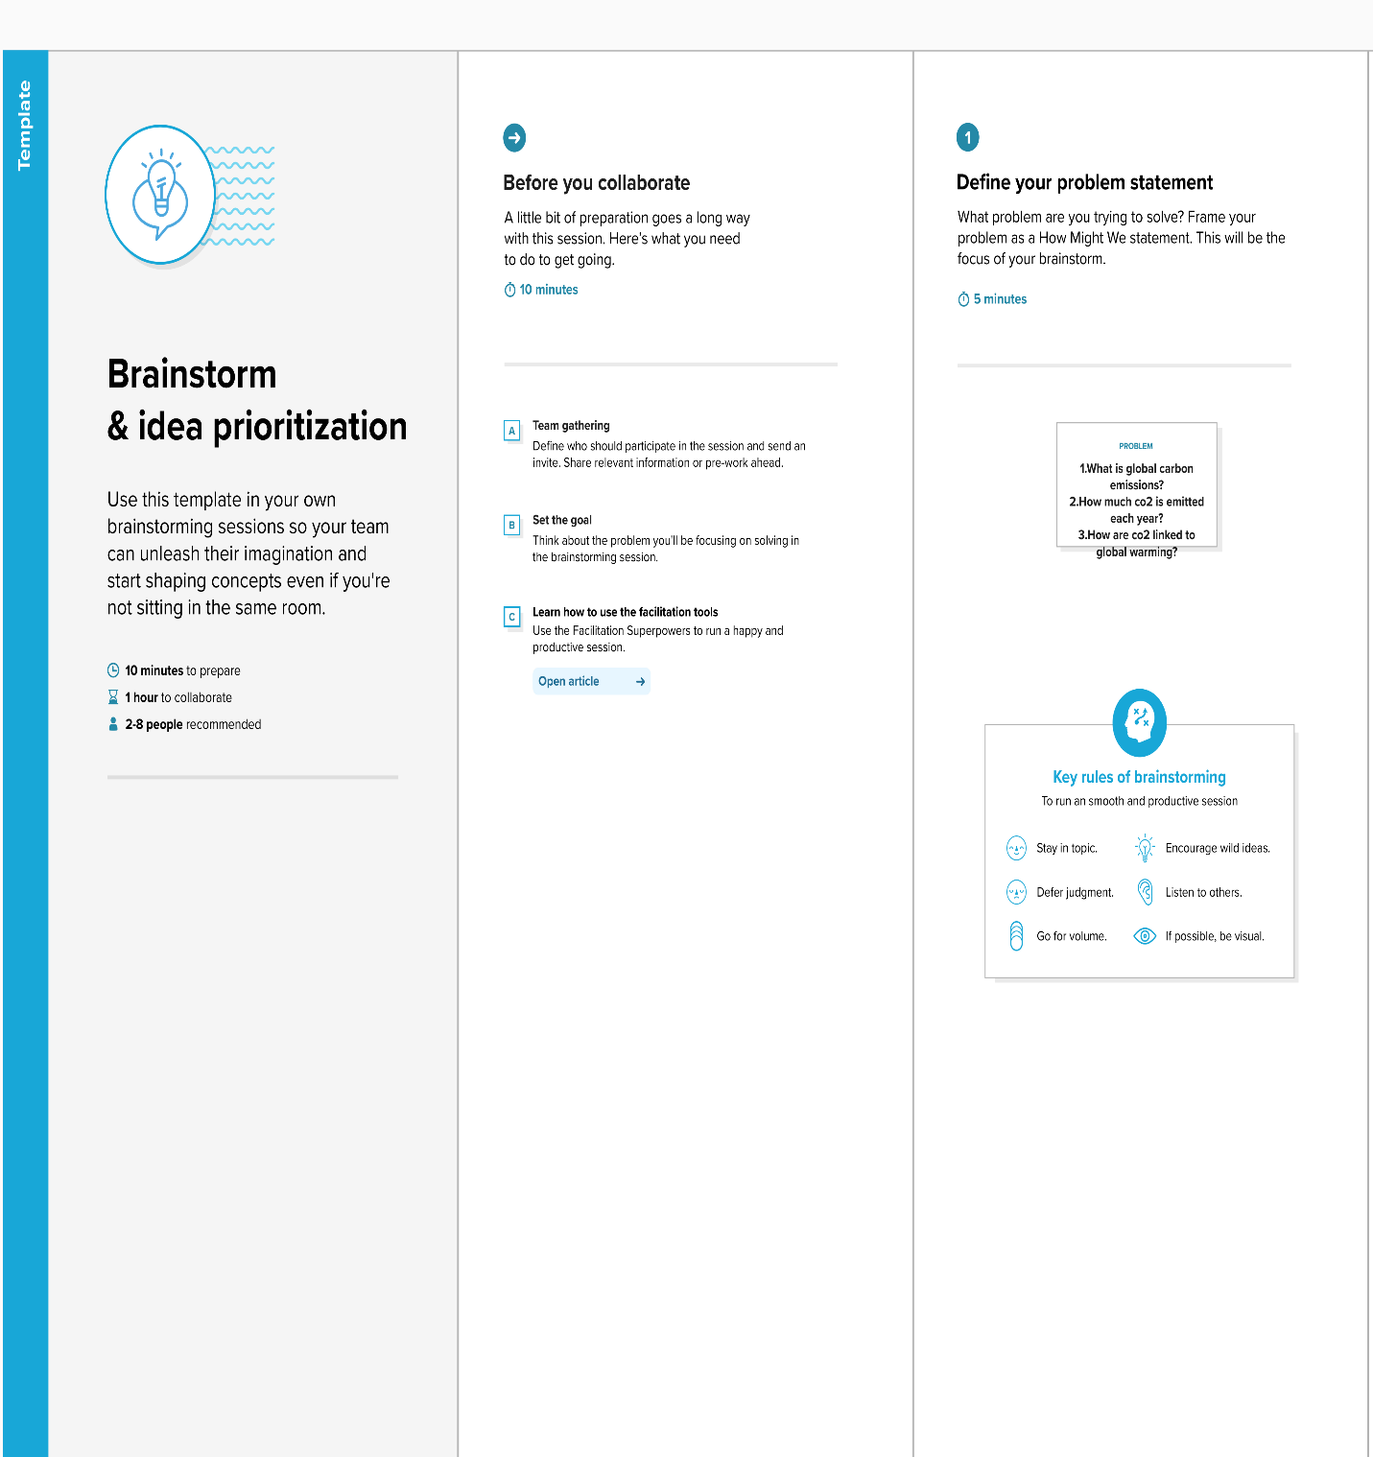

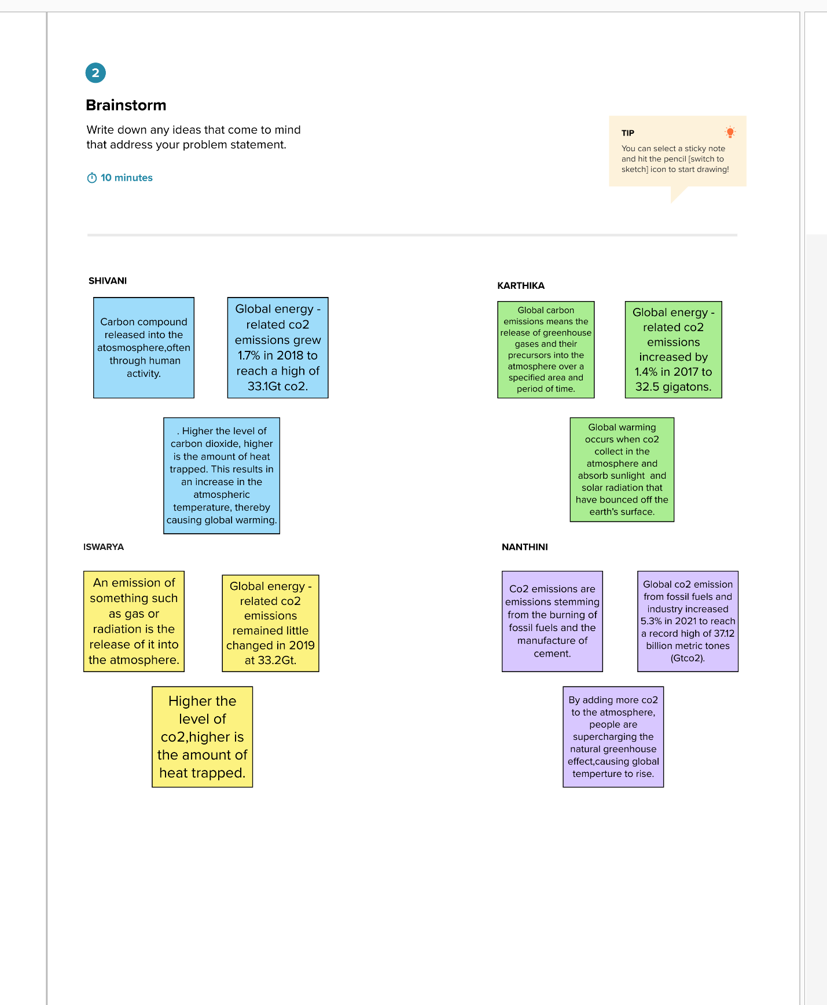

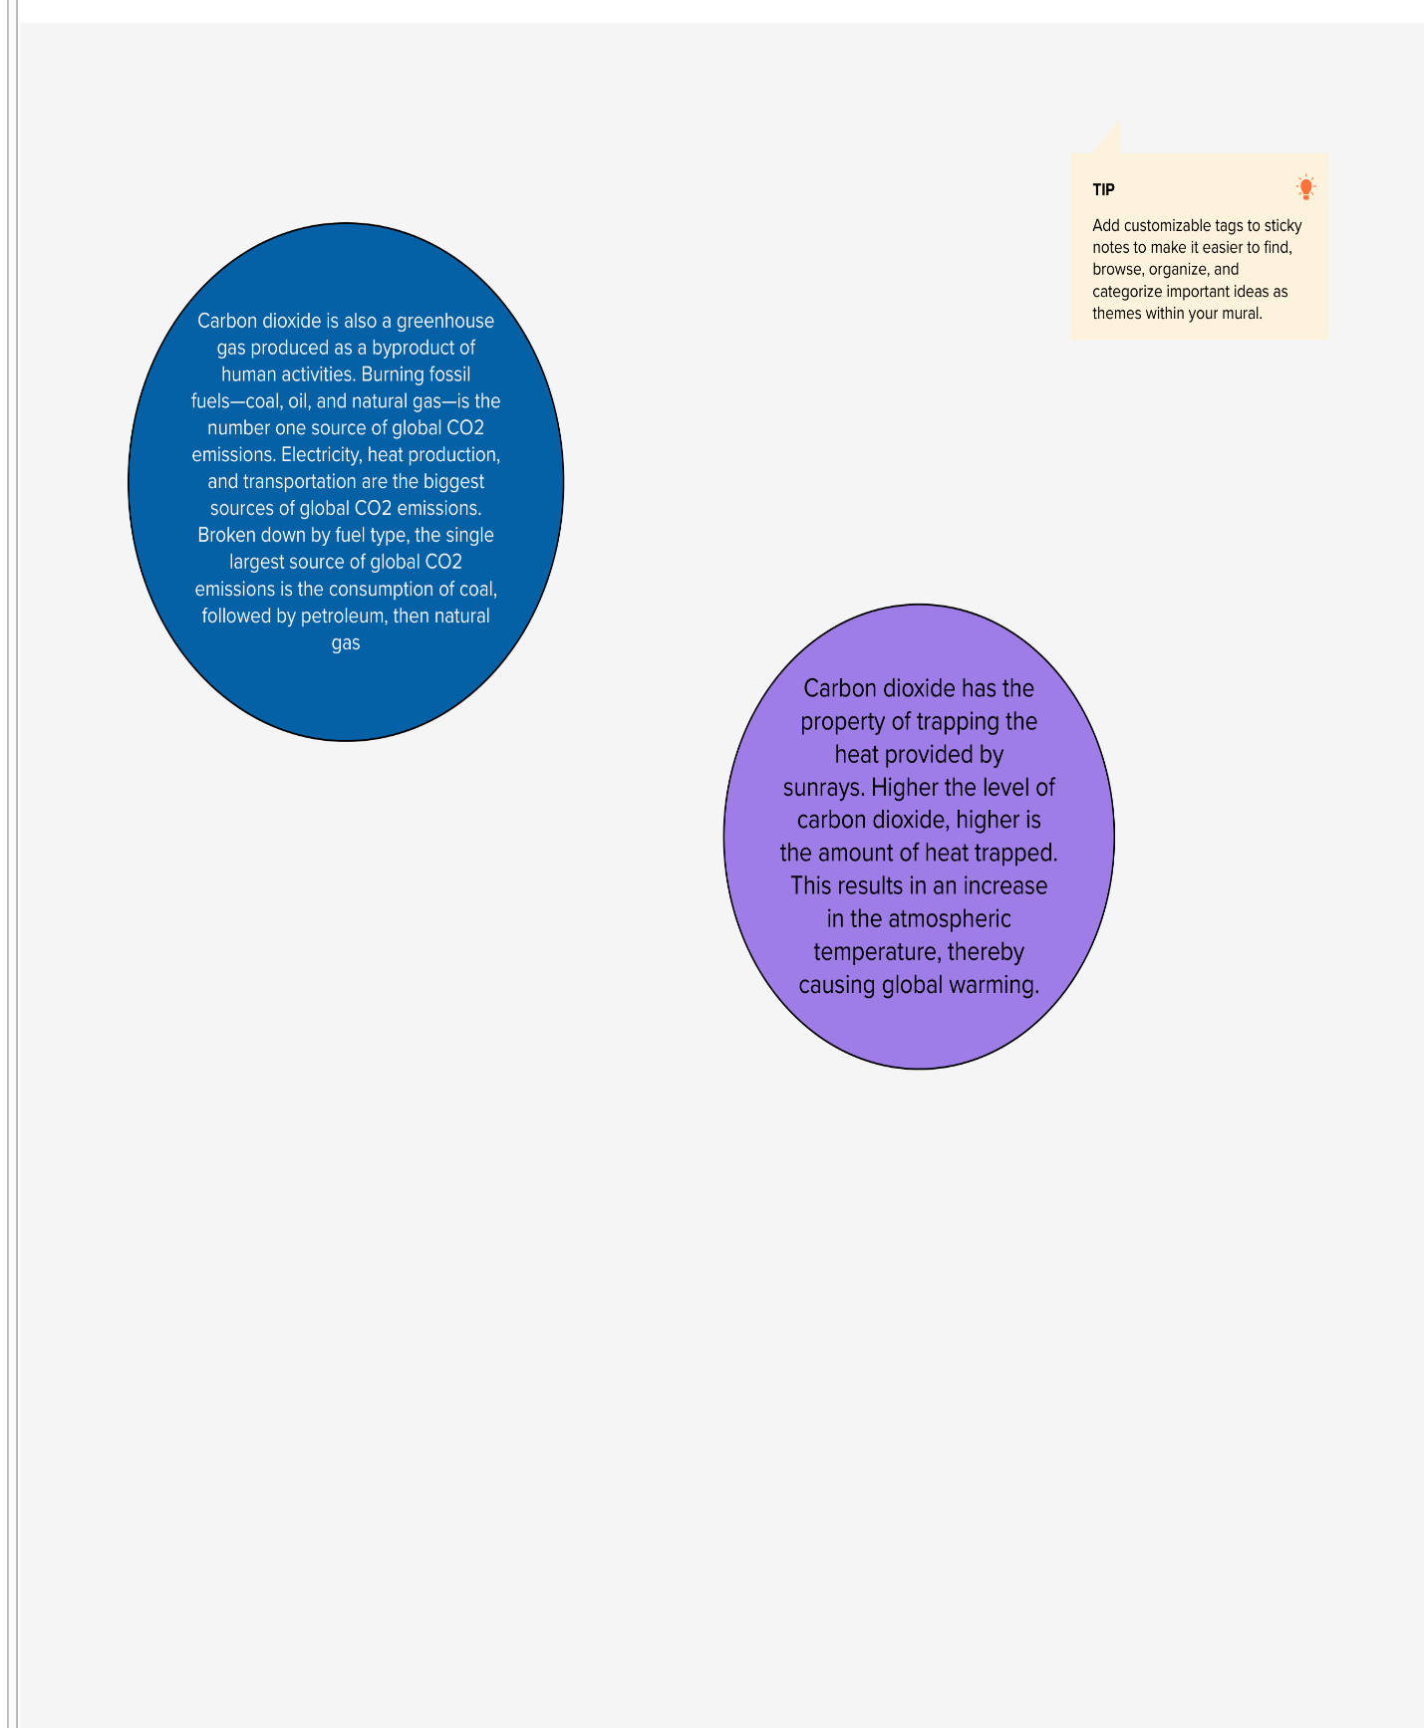

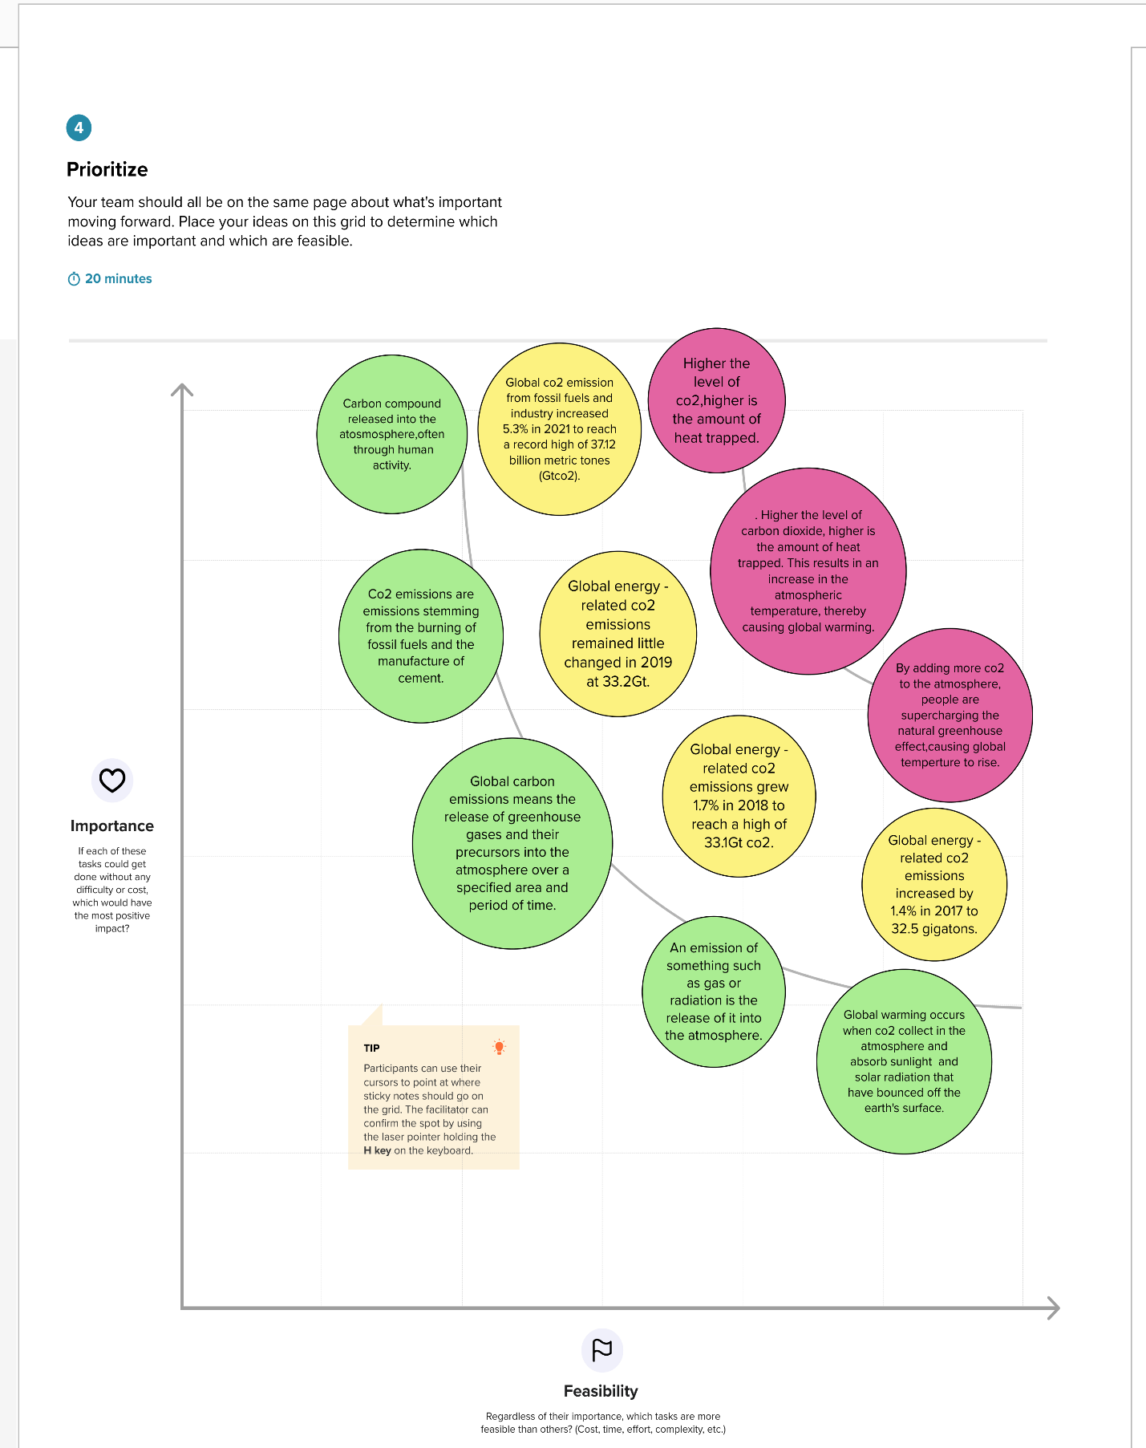

**ACTIVITY 1.1**

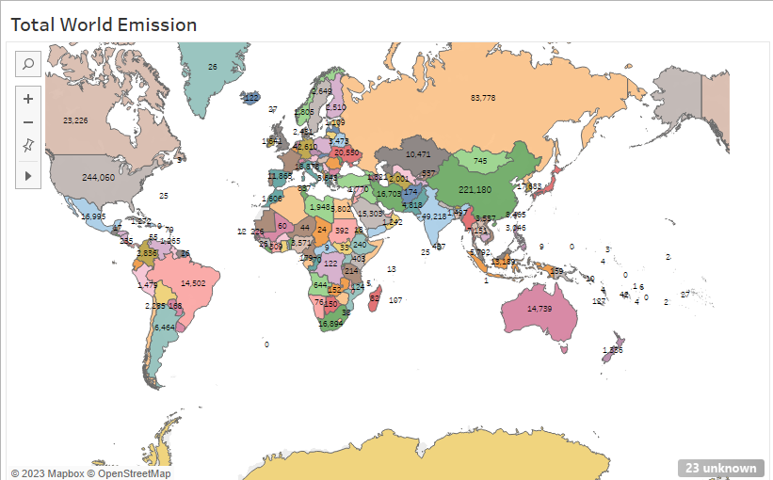

**ACTIVITY 1.1**

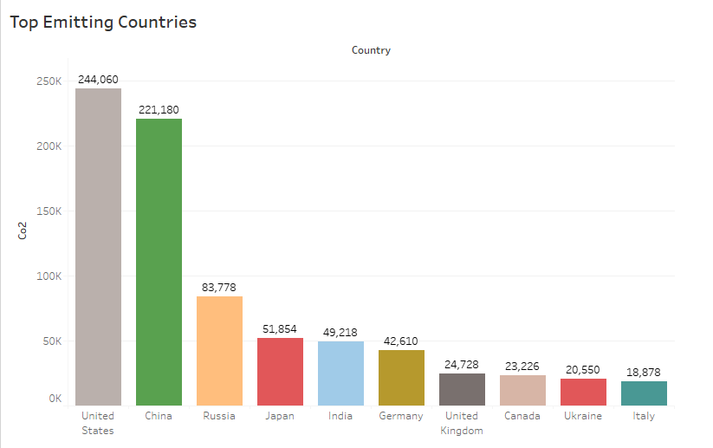

**ACTIVITY1.3**

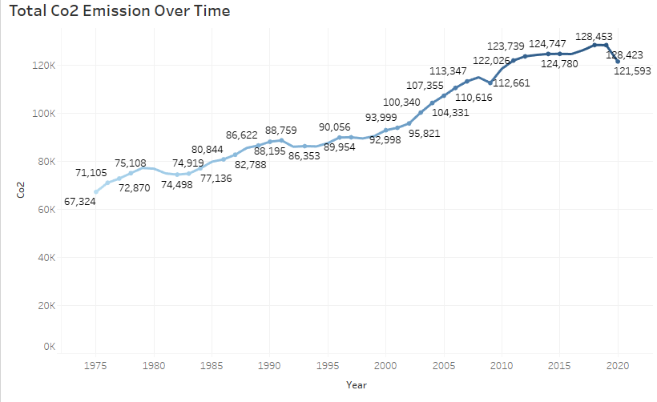

**ACITIVITY 1.4**

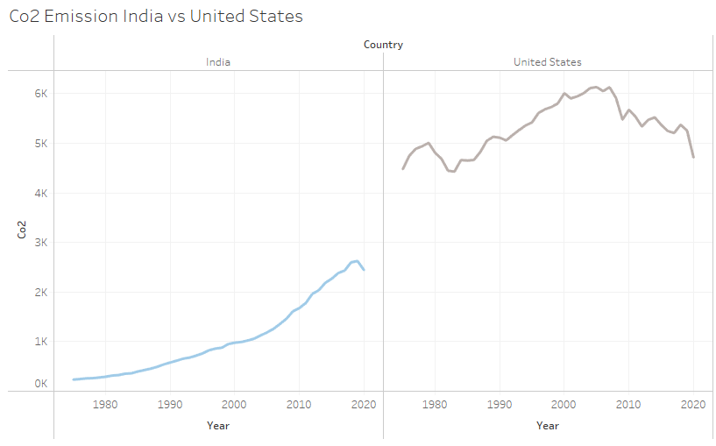

**ACITIVITY 1.5**

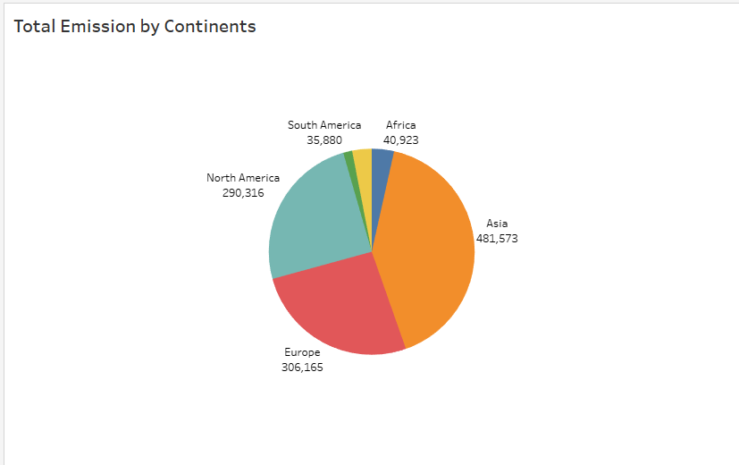

**ACITIVITY 1.6**

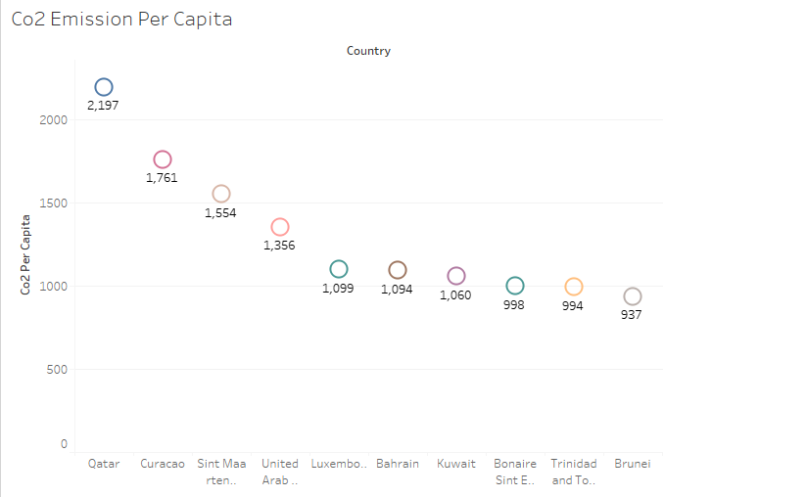

**ACITIVITY 1.7**

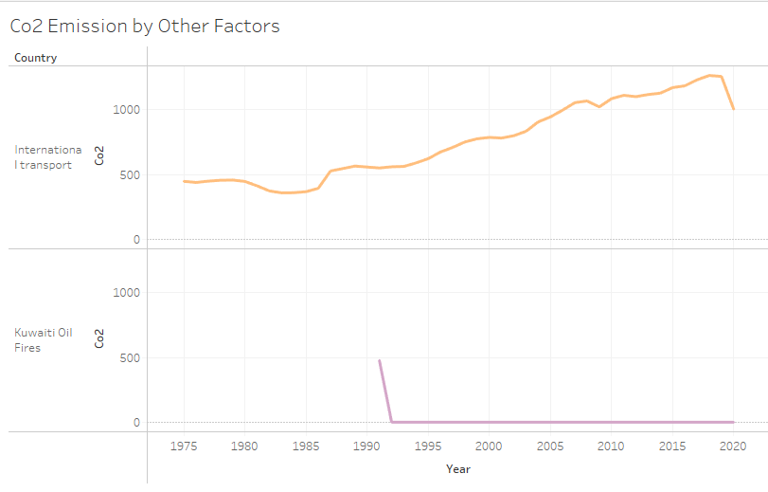

**ACITIVITY 1.8**

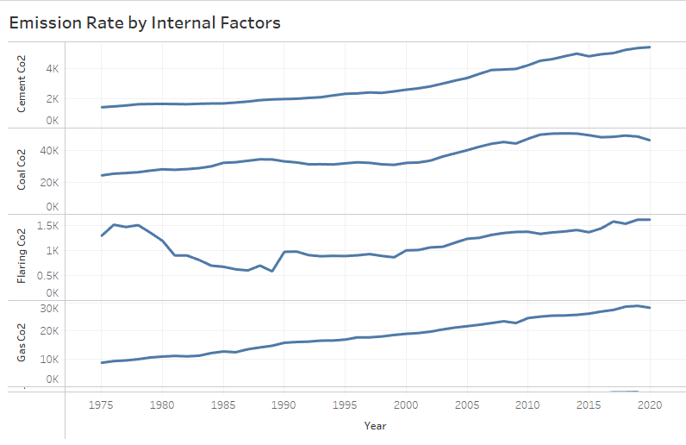

**ACITIVITY 1.9**

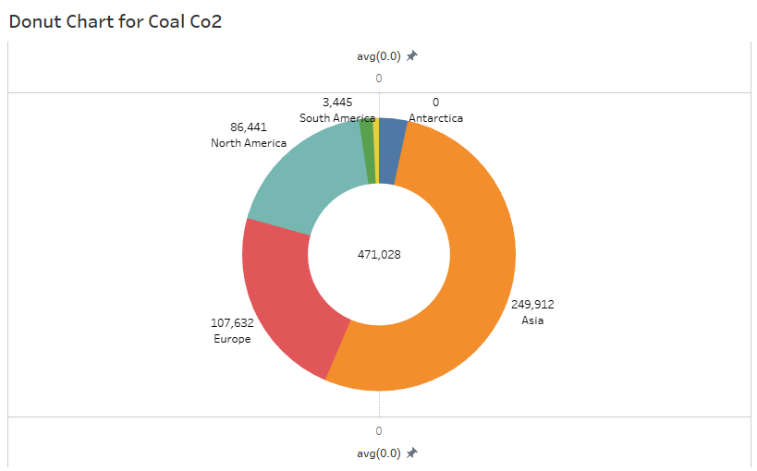

**ACITIVITY 1.10**

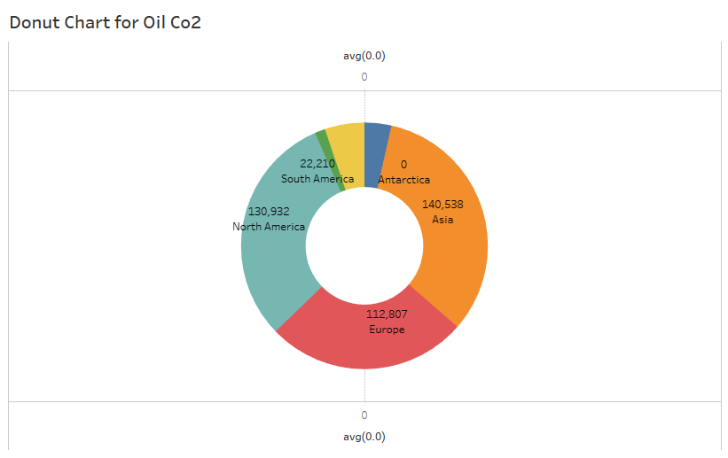

**ACITIVITY 1.11**

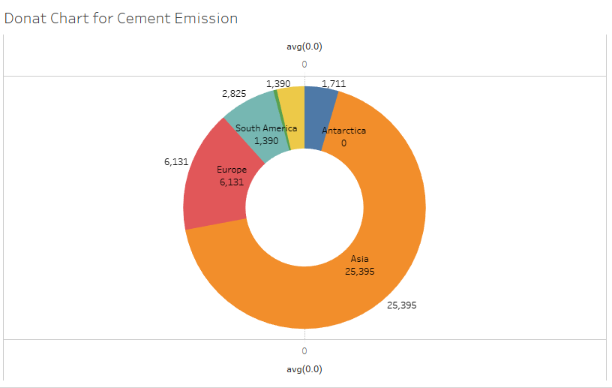

**ACITIVITY 1.12**

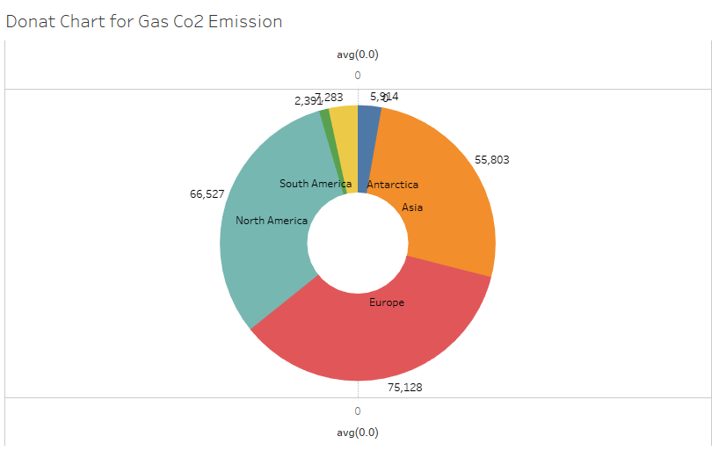

**ACITIVITY 1.13**

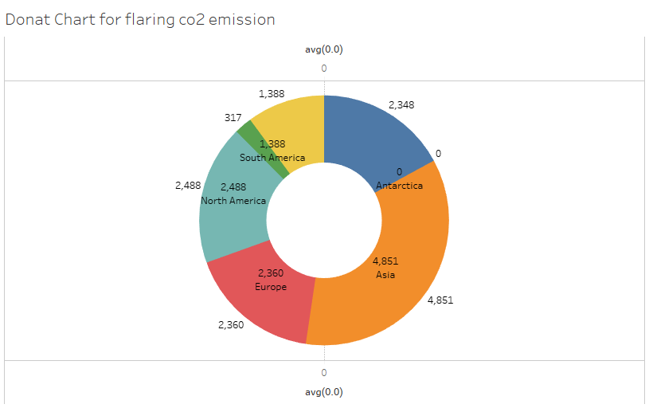

**ACITIVITY 1.14**

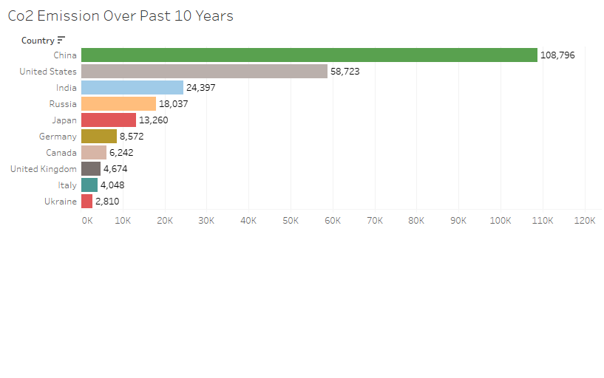

**ACITIVITY 1.15**

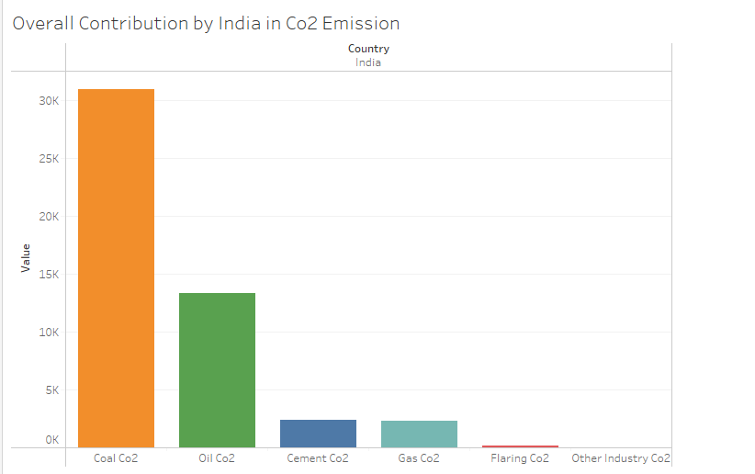

**ACITIVITY 1.16**

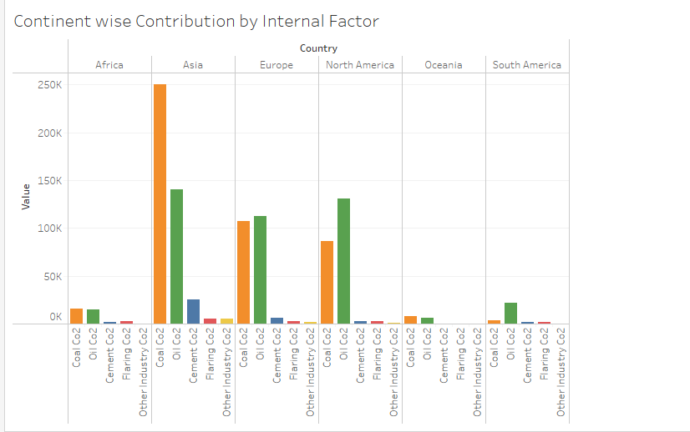

**ACITIVITY 1.17**

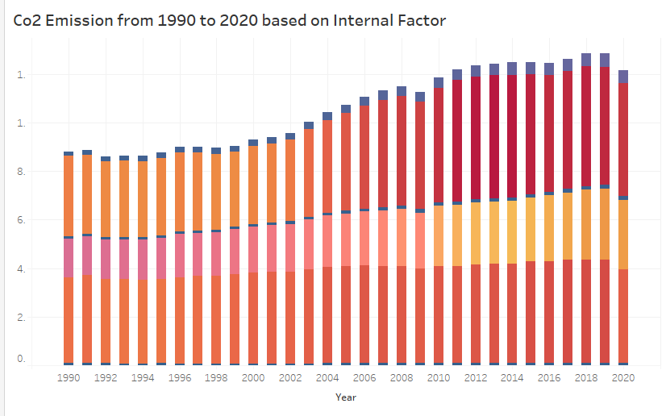

**ACITIVITY 1.18**

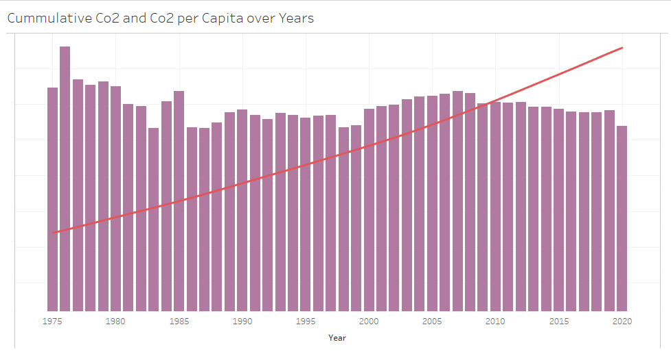

**ACITIVITY 1.19**

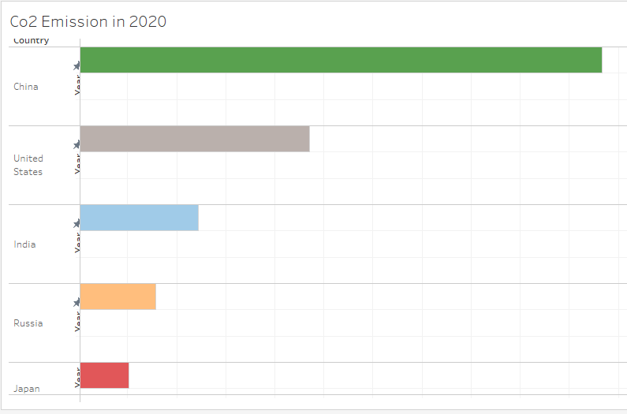

**ACITIVITY 1.20**

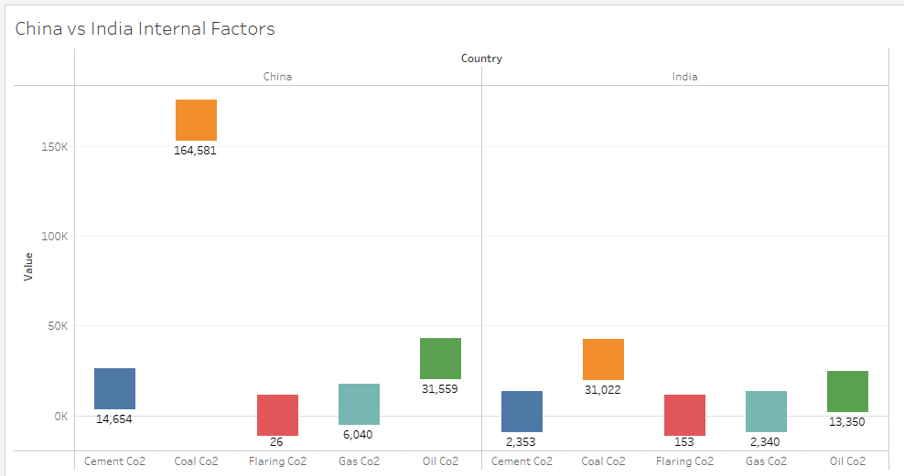

**ACITIVITY 1.21**

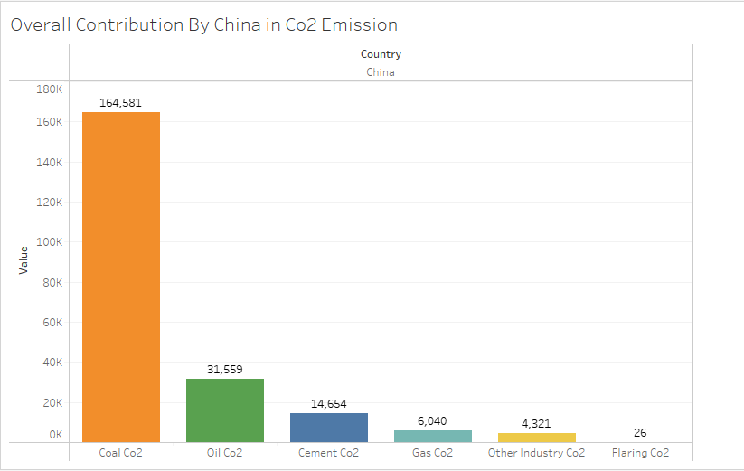

**ADVANTAGES:**

1.Carbon dioxide is an important greenhouse gas that helps to trap heat in our atmosphere. Without it, our planet would be inhospitably cold.

2.Carbon dioxide plays a key role in Earth's carbon cycle, the set of processes that cycle carbon in many forms throughout our environment. Volcanic outgassing and wildfires are two significant natural sources of CO2 in Earth's atmosphere

3. Green plants grow faster with more CO2. Many also become more drought- resistant because higher CO2 levels allow plants to use water more efficiently.

**DISADVANTAGES**

1.High carbon dioxide levels can cause poor air quality and can even extinguish pilot lights on gas-powered appliances.

2. Emissions of greenhouse gases, predominantly carbon dioxide, have been steadily increasing and kicking the greenhouse effect out of balance

3.The health effects of Co2 Emission are increased respiratory and cardiovascular disease, injuries and premature deaths related to extreme weather events, changes in the prevalence and geographical distribution of food- and water-borne illnesses and other infectious diseases, and threats to mental health.

APPLICATIONS

1. CO2 can be used as an alternative to fossil fuels in the production of chemicals, including plastics, fibers and synthetic rubber.

2. Carbon dioxide is used as a refrigerant, in fire extinguishers, for inflating life rafts and life jackets, blasting coal, foaming rubber and plastics, promoting the growth of plants in greenhouses, immobilizing animals before slaughter, and in carbonated beverages.

3. CO2 is also widely used in food and beverage production, the fabrication of metal, cooling, fire suppression and in greenhouses to stimulate plant growth.

4. CO 2 is a versatile industrial material, used, for example, as an inert gas in welding and fire extinguishers, as a pressurizing gas in air guns and oil recovery, and as a supercritical fluid solvent in decaffeination of coffee and supercritical drying.

**CONCLUSION**

*From the project we conclude about the CO2 Emission, we conclude this using the following charts*

* Total World Emission
* Top Countries Emission
* Co2 Emission Over Time
* Co2 Emission India vs US
* Total Emission by Continents
* Co2 Emission Per Capita
* Co2 Emission by Other Factors
* Emission Rate Over Years
* Donut Chart for Oil Co2, Coal Co2, Cement Emission, Gas Co2 Emission, flaring co2 emission
* Co2 Emission Over Past 10 Years
* Overall Contribution by India in Co2 Emission
* Continent wise Contribution by Internal Factor
* Change in CO2 emission
* Cumulative Co2 and Co2 per Capita over Years
* Co2 Emission in 2020
* China vs India Internal Factors
* Overall Contribution by China in Co2 Emission

**FUTURE SCOPE:**

EIA’s *International Energy Outlook 2021*(IEO2021) Reference case projects that if current policy and technology trends continue, global energy consumption and energy-related CO**2** emissions will increase from 2020 through 2050 as a result of population and economic growth. However, projected future growth in energy-related CO**2** emissions is not evenly distributed across the world, and the majority of the projected future growth in energy-related CO**2** emissions is among the group of countries outside the Organization for Economic Cooperation and Development.

**SOURCE CODE**

***For further information Click the link below***

***DASHBOARD***

[***https://public.tableau.com/views/co2emissionDashboard1/Dashboard1?:language=en-US&:display_count=n&:origin=viz_share_link***](https://public.tableau.com/views/co2emissionDashboard1/Dashboard1?:language=en-US&:display_count=n&:origin=viz_share_link)

***STORY***

[***https://public.tableau.com/views/co2emissionStory_16818014818250/Co2EmissionStory?:language=en-US&:display_count=n&:origin=viz_share_link***](https://public.tableau.com/views/co2emissionStory_16818014818250/Co2EmissionStory?:language=en-US&:display_count=n&:origin=viz_share_link)

***WEB LINK***

***file:///C:/Users/ELCOT/Documents/shiv/Arsha/index.html***